**Unit 1 Measurement in Physics and 1-D motion**

**IB 1.1, 1.2, 2.1 Review Worksheet Name: _______________________**

1. **Convert between Scientific Notation and Standard Notation**
   1. 0.00000978 L ______________
   2. 837,100,000 cm3 ______________
   3. 0.005930 g ______________
   4. 6.130 x 10-9 m ______________
   5. 1.2552 x 107 J ______________
   6. 1.05 x 109 Hz ______________
2. Perform the following conversions using dimensional analysis. (Factor label method.) Show your work.

a. 78.92 m3  to L

b. 3.97 m/s2 to ft/min2

1. **For each time interval (e.g. A to B), describe the motion represented by the following position versus time or velocity versus time graphs.**

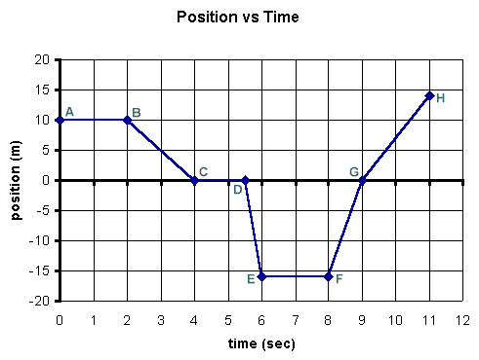



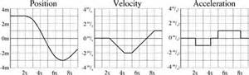

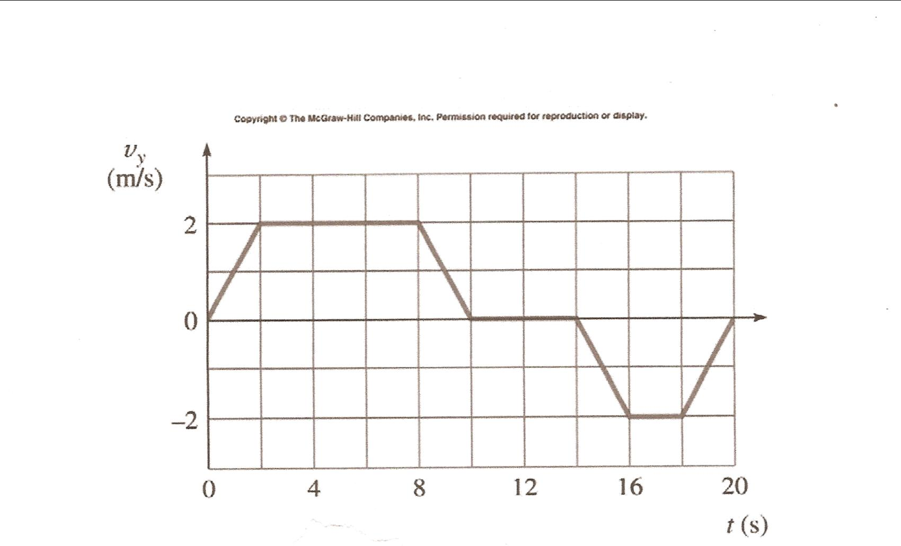

1. **Complete the following table by drawing the x vs t and v vs t graphs or describing the motion as needed.**

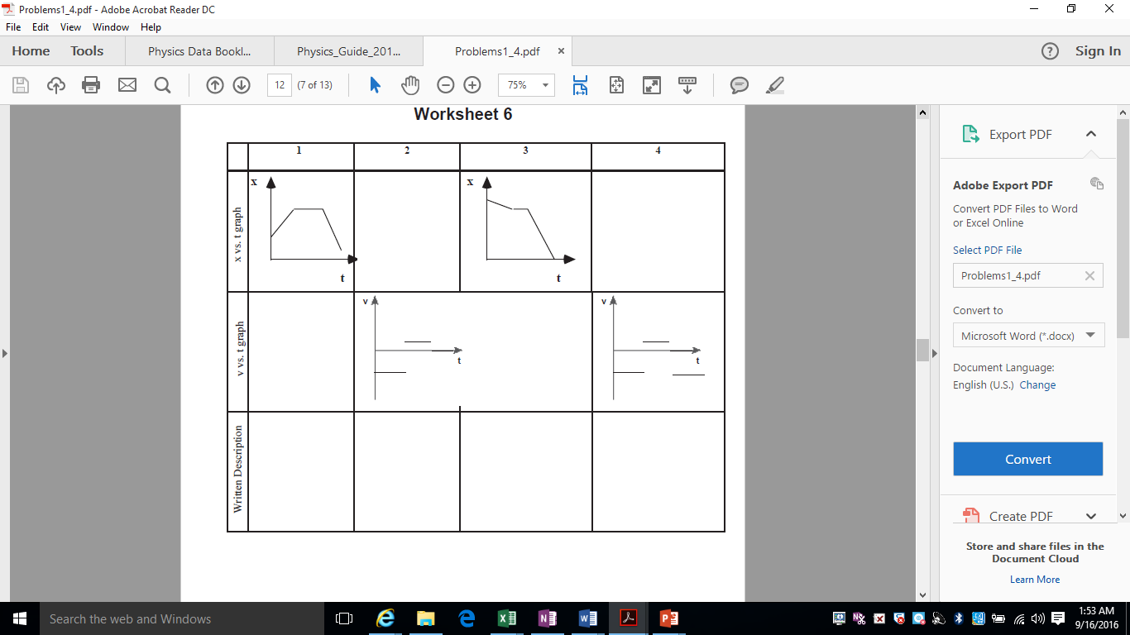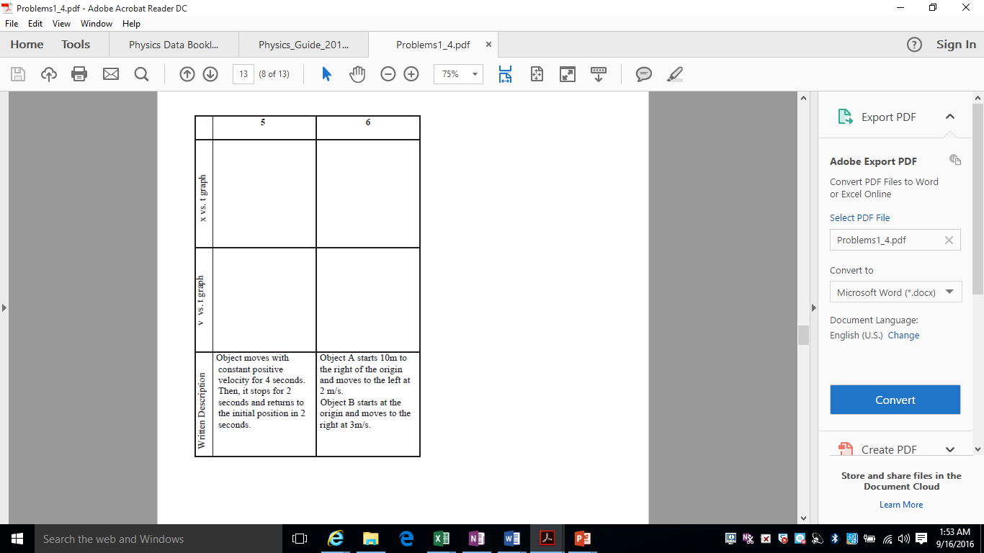

1. **Consider the following graph. Determine the equation of the best fit line. Then use a min and max line to assess the uncertainty in the slope and intercept of the best fit line. See** [**https://www.youtube.com/watch?v=5Nl39d5D7lo**](https://www.youtube.com/watch?v=5Nl39d5D7lo) **for help. (Note that he uses actual data points because they happen to lie directly on the line. In general, do not use data points, but choose points ON THE LINE)**

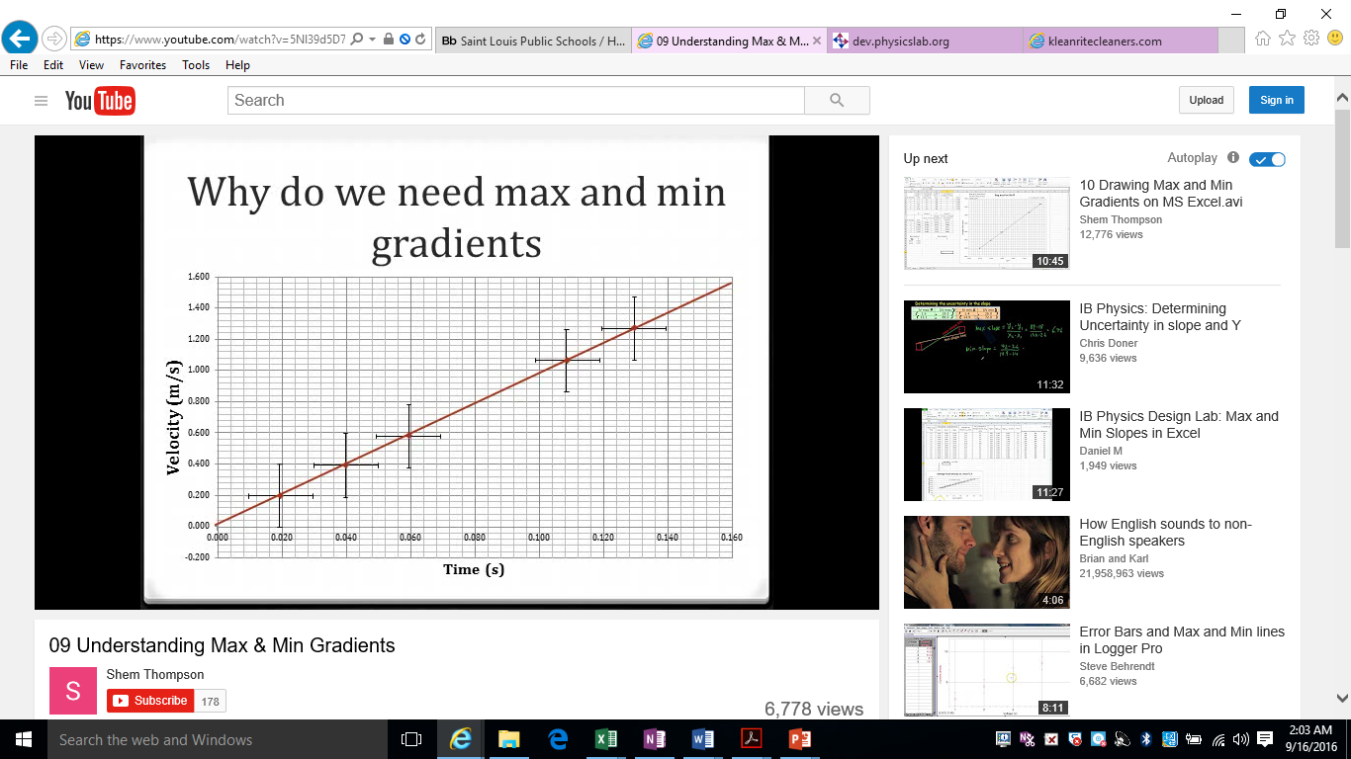

**b. Try another one. The best fit line is already completed here. Assess the uncertainty in the gradient and intercept. Then see:** [**https://www.youtube.com/watch?v=Bkp6nHoS_p4**](https://www.youtube.com/watch?v=Bkp6nHoS_p4) **to check your answer.**

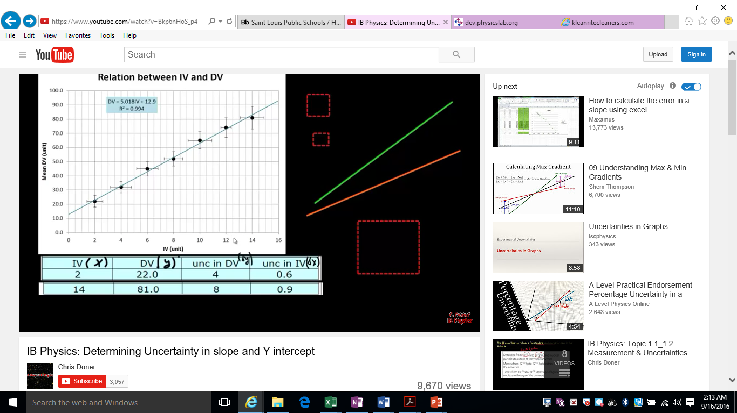

1. **Given the following values, determine the indicated quantities with their uncertainties.**

**A = 15.3 ± 0.3**

**B = 3.54 ± 0.05**

**C = 0.046 ± 0.008**

1. **Q = A + B**
2. **Q = AC**
3. **Q = B2**

1. **Estimate the following to a one sigfig order of magnitude. Justify your answer**
   1. The average number of hairs on a person’s head.
   2. The number of pages in an encyclopedia set that fills a 1 m wide two shelf bookcase.
   3. The number of carbon atoms in a newborn baby.
2. **Solve the following problems with no acceleration.**
   1. Calculate the total displacement and the total distance of a mouse walking along a ruler, if it begins at the position x = 5cm, and then does the following:

- It walks to x = 12cm

- It then walks a displacement of -8cm

- Lastly, it walks to the location x = 7cm

* 1. Find the average velocity (in m/s) of a bicycler that starts 150 meters north of town and is 1200 meters north of town after 30.0 minutes.

1. **Solve the following constant acceleration problems.**
   1. A boat moves slowly inside a marina with a constant speed of 1.50 m/s. As soon as it leaves the marina, it accelerates at 2.40 m/s2. How fast is the boat moving after accelerating for 5.00 s? How far has the boat traveled in this time?
   2. A rocket blasts off and moves straight upward from the launch pad with constant acceleration. After 3.0 s the rocket is at a height of 77 m. What are the magnitude and direction of the rocket’s acceleration? What is its velocity at this time?
2. **Solve the following freefall problems.**
   1. You shoot an arrow into the air. Two seconds later the arrow has gone straight upward to a height of 30.0 m above it’s launch point. What was the arrow’s initial velocity? How long did it take for the arrow to first reach a height of 15.0 m above its launch point?
   2. A gull ascending straight upward at 5.20 m/s drops a shell when it is 12.5 m above the groun. What are the magnitude and direction of the shell’s acceleration just after it is release? Find the maximum height above the ground reached by the shell. How long does it take for the shell to reach the ground? What is the velocity of the shell at this time?